Path parameters are variable elements of a URL that you use to identify a specific resource in a collection. This allows you to send an API call that refers to a specific resource, rather than a collection of resources. For example, if you want to retrieve information about a specific user, rather than every user on the account, a path parameter allows you to do this.

Where an endpoint accepts a path parameter, it is denoted in its URL between a pair of braces {}.

For example:

/users/{userId} ← indicates that the endpoint accepts a path parameter called userId. When you make an API call, you replace the braces and the placeholder inside the braces with the value you want to refer to.

A path parameter normally refers to a resource by its unique identifier. For example, if you want to refer to a user with a userId of "20", the request URL would be:

/users/20.

It is also possible for a URL to contain multiple path parameters, for example: /client/{clientId}/department/{departmentId}/employees.

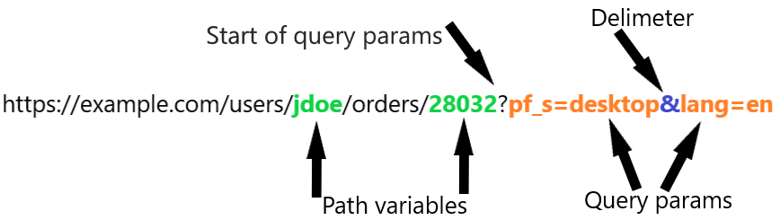

Typically query parameter is use as a filter. For e.g. if the response can have a lot of pages, then you can query for a specific page number using the query parameter. Of course, if the dev has got it implemented.

Path parameter on the other hand can be used for fetching a specific resource. For e.g. From the given workspaces, I want to fetch a specific workspace with it's ID. I can use it as a path parameter. Of course, if the developer has got it implemented.

I hope it's clear now. These are developer things and they will have many other reasons to go for either query parameter or for path parameter.

For the rest assured thing, it's just the rest assured's way of providing us an option to use pathParam() method to send the path parameter instead of putting it in the URL. This may add readability to the test case. For e.g. We can pass access token using header() method, but then rest assured has got a method called OAuth() that can be used to pass the access token. If the token is an OAuth2.0 token, it would make sense to use the method instead of passing the token using header. This gives some meaning to what we are doing.